Vertica Frontend Case

## What is this?

This assignment is meant as a starting point for a technical interview, meaning you will not be assessed solely based on the code you hand in. This means we are just as much interested in unfinished clever ideas and concepts as we are in the general state of the codebase. Consequently, the assignment is loosely described by design, to allow for you to steer the interview in a direction where you can show us your strengths – be that design, animations, server-side rendering or something else entirely.

We expect no more than a couple of hours of work, but you are free to spend as much time as you like.

## What to build?

The general assignment is creating a simple website comprised of elements we typically see on ecommerce sites. Your site should have the following (links and drawings are only inspiration):

* A page showing a list of products (eg. <https://demo.vercel.store/search/shirts>)
* A details page focusing on one product (eg. <https://demo.vercel.store/product/acme-t-shirt>)
* Data should come from an external API
  + We suggest <https://fakestoreapi.com>, but if you are more comfortable with something else, feel free to use that instead.
* The details page should be accessed by the list page (by routing, a modal or something similar)
* From here your time and imaginations sets the limit.

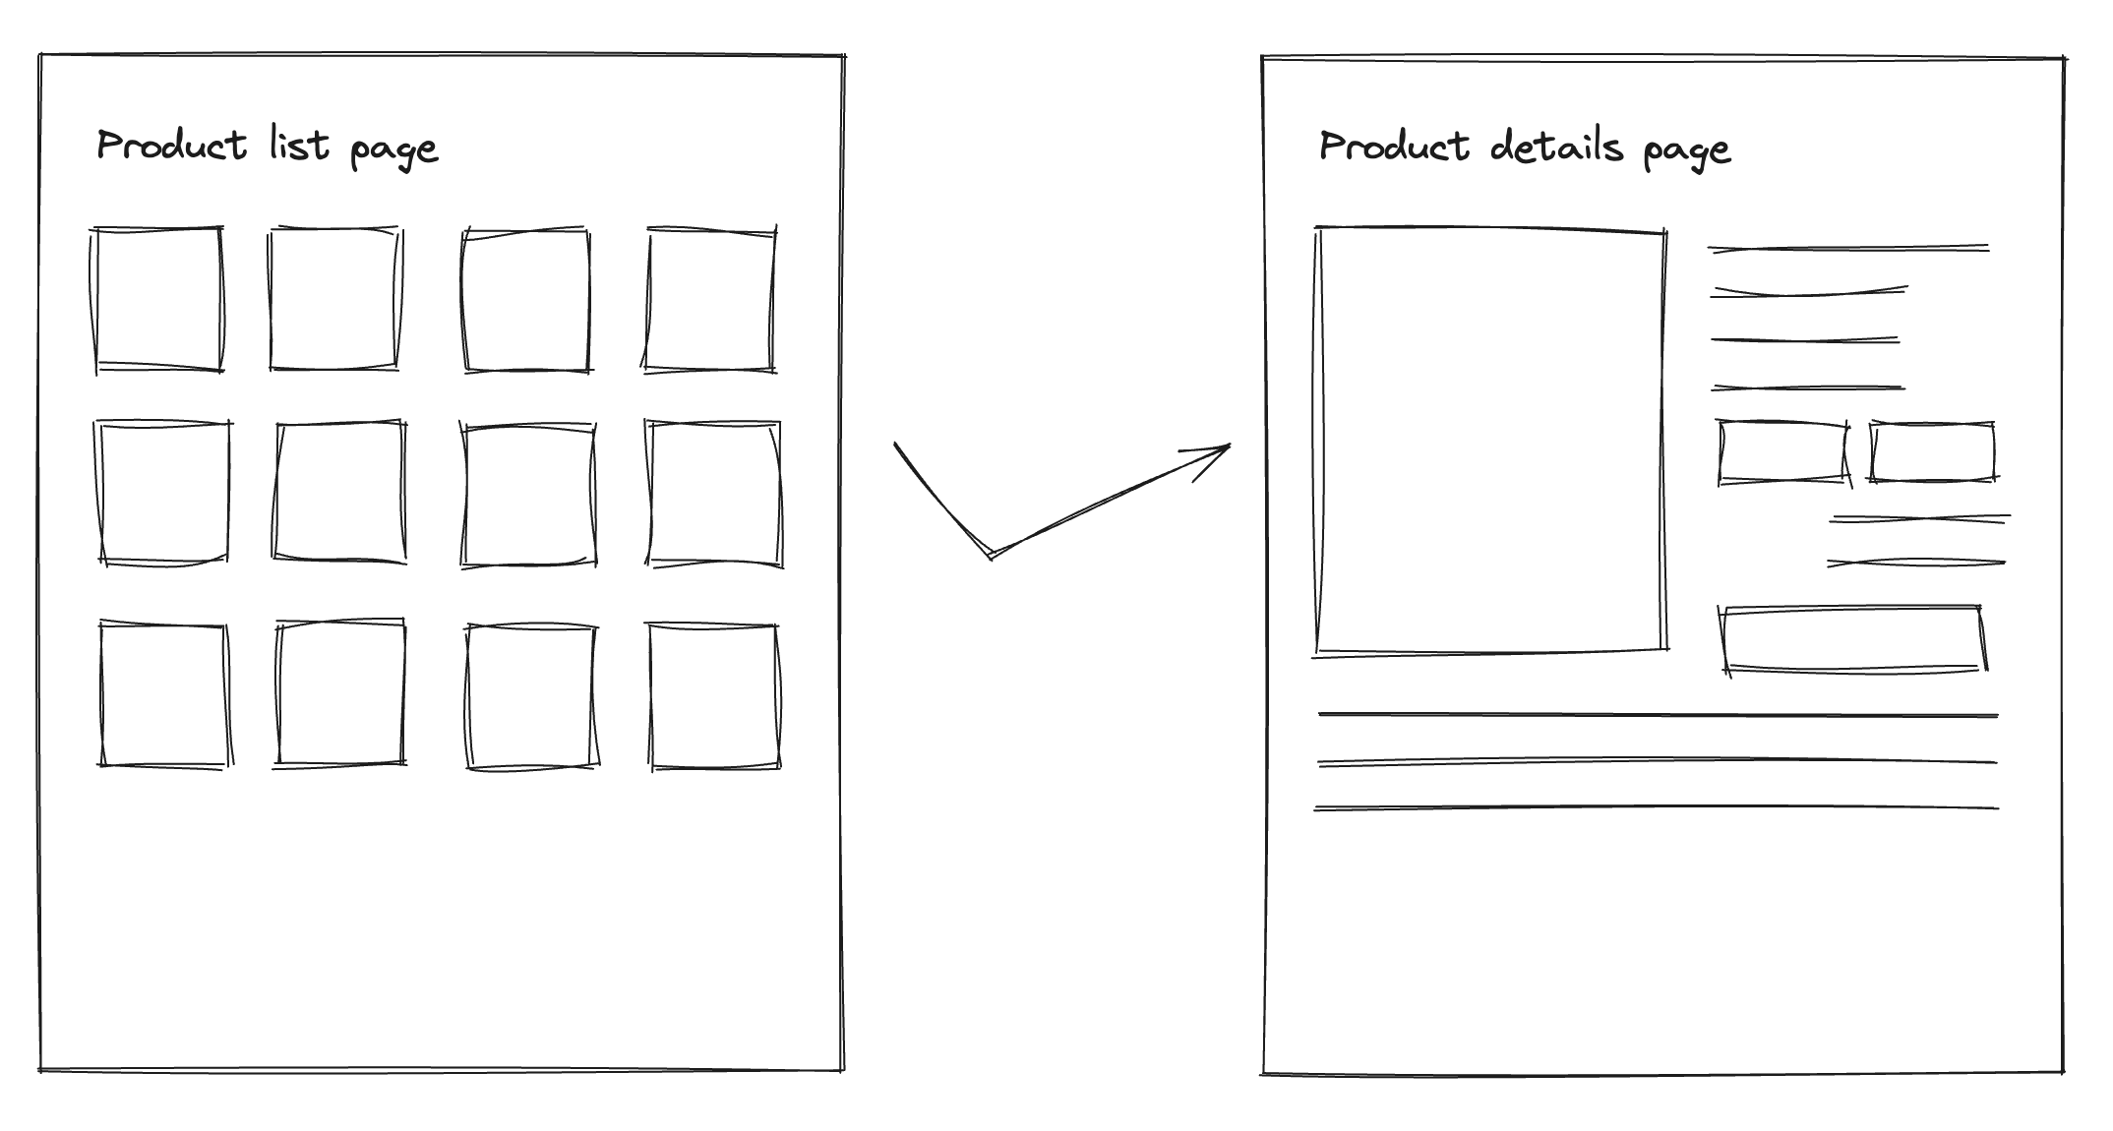

## A Note About Tech

You are free to choose a frontend library, framework or meta framework, if any at all. We use Vue and React at Vertica, so if you are comfortable with either, please use those. However, we will happily talk about the likes of Angular or vanilla JavaScript as well. Likewise, you are free to use any supporting libraries you want, but we might ask about the reasoning behind such a choice.

You are provided with a baseline project for both React and Vue, but feel free to start a new project yourself, this is merely for convenience.

*Code should be handed in as a zip or access to a repo.*  
*If you have projects, you are particularly proud of, you can bring them on the day (Not expected!).*